In Excel click the File button from the top center tab menu.
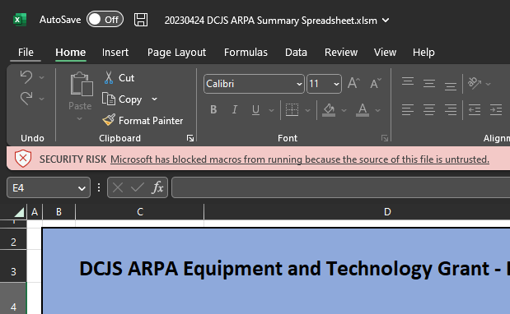
Then Click Options from the bottom right.
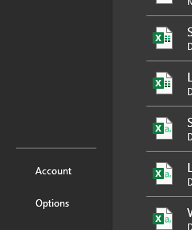
On the options pane, select Trust Center from the left side tab menu,
Then press Trust Center Settings

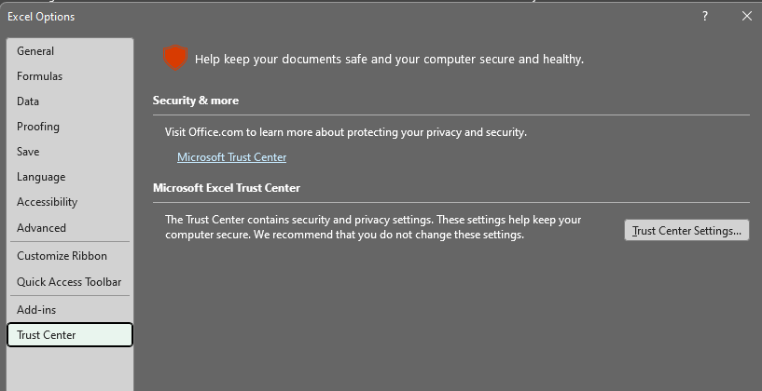
On the Trust Center pane, select Trusted Locations.
Then click Add New Location.. in the center of the window.
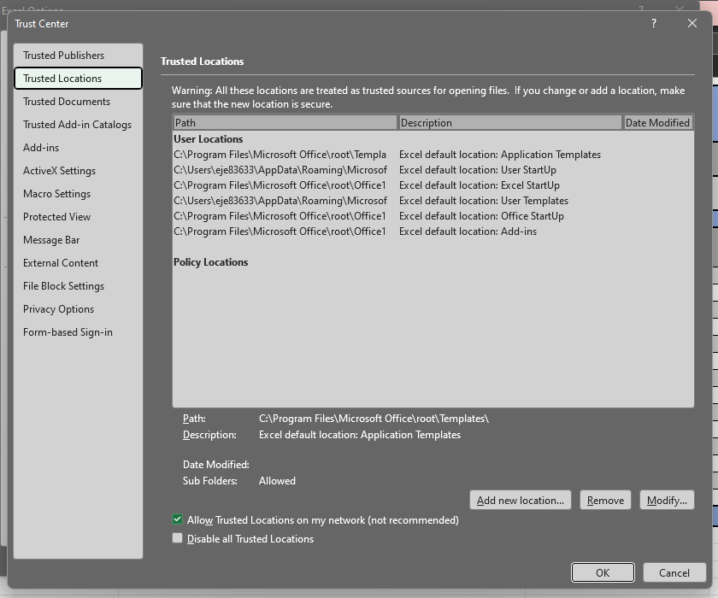
On the next window click Browse
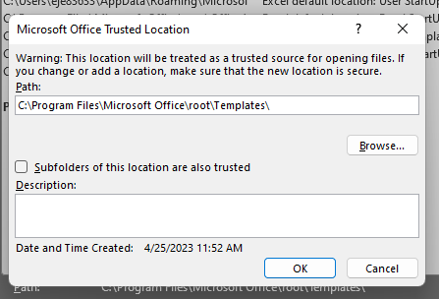
This will bring up a file explorer window. You will want to select Users and then select your user profile folder. If you don’t know your username, it should be the folder with the most recent date modified.
Then click OK.
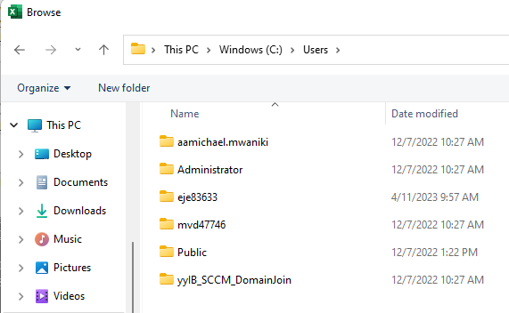
Then make sure the Checkbox labeled Subfolders of this location are also trusted is checked and click Ok again.
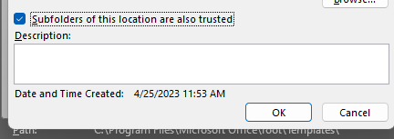
Then click Ok on the Trust Center and Options windows to save your changes.
The document should now be accessible.

